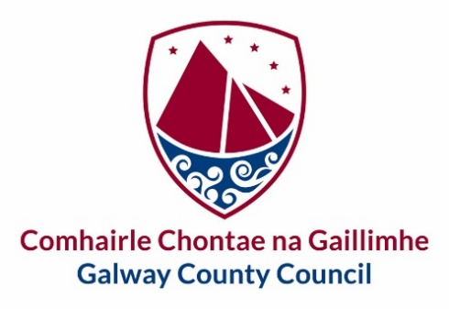

**Oranmore Town Team – Expressions of Interest**

Galway County Council would like to invite expressions of interest from the local community to create a dedicated Town Centre First (TCF) Town Team for Oranmore. A TCF Town Team is a group of local residents, businesspeople, community representatives and other stakeholders who come together to make their area a better place to live, work, study and visit. TCF Town Team members may come from diverse sectors and backgrounds. They have a unique position in the community to become ‘local experts’ on their area and to take a lead on the development of projects that can make positive long-term changes for the town.

The TCF Town Team will work closely alongside the Town Regeneration Officer and the Council’s multi-disciplinary Regeneration team. Members must work on behalf of the community as a whole and not in their own interests or in the interests of an individual or a specific group(s).

After the closing of this call for expressions of Interest a shortlist of applicants will be created.

Please register your interest by submitting the Expression of Interest Form via e-mail to [regeneration@galwaycoco.ie](mailto:regeneration@galwaycoco.ie) or by post to Urban & Rural Regeneration Team, Economic Development and Planning, Rural Aras an Chontae, Prospect Hill, Galway H91 H6KX.

**Closing date for applications is Wednesday 21st of August.**

|  |  |  |  |
| --- | --- | --- | --- |
| gcc logob stacked.png |  | | **Oranmore Town Team - Participation Forum** |
| **Tá an fhoirm seo le fáil i gcló mór chomh maith** | | This form is also available in large print | |
| **Tá míle fáilte an fhoirm seo a líonadh i nGaeilge** | | | |

|  |
| --- |
| **Expression of Interest Form** |

|  |  |
| --- | --- |
| Are you part of an existing Community/sport or other group? If yes, please give details below | Yes No |
| Name of Group/s: (as relevant) |  |
|  |
|  |
| Role of Nominee within existing group: |  |
| Please indicate your area of interest, select 1 only:  Culture & Built Heritage  Community & Sports and recreation  Economic Development & Tourism  Vacancy and Dereliction  Public spaces & streetscapes  Natural environment & Biodiversity |  |
| Please indicate why you want to be part of the Oranmore Town team? |  |
| Would be interested in a lead role within the Town Team,  Please select 1 role:  Chairperson  Secretary  Town Champion |  |
| Contact Telephone number for Nominee: |  |
| **Contact E-mail for Nominee:** |  |

|  |  |
| --- | --- |
| Name (in block capitals): |  |
| Signed: |  |
| Date: |  |

|  |  |  |
| --- | --- | --- |
| **Seol an fhoirm ar ais chuig:**  **Athghiniúint Tuaithe**  **Comhairle Chontae na Gaillimhe**  **Áras an Chontae**  **Cnoc na Radharc**  **Gaillimh**  **H91 H6KX** | Return to:  Regeneration Team  Galway County Council  Áras an Chontae  Prospect Hill  Galway  H91 H6KX | [regeneration@galwaycoco.ie](mailto:regeneration@galwaycoco.ie)  www.gaillimh.ie  www.galway.ie |